**Creating Add-Ins**

To create an Add-In from scratch:

Open an empty Workbook

Run VB editor and create, add a module and create for example a function in it

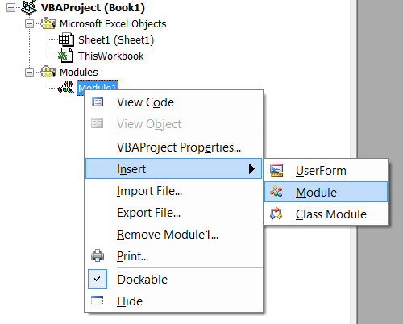

Public Function Reverse(ByVal aString As String) As String

Dim rev As String

Dim i As Integer

rev = ""

For i = Len(aString) To 1 Step -1

rev = rev & Mid(aString, i, 1)

Next

Reverse = rev

End Function

Save .xlam file to the file system.

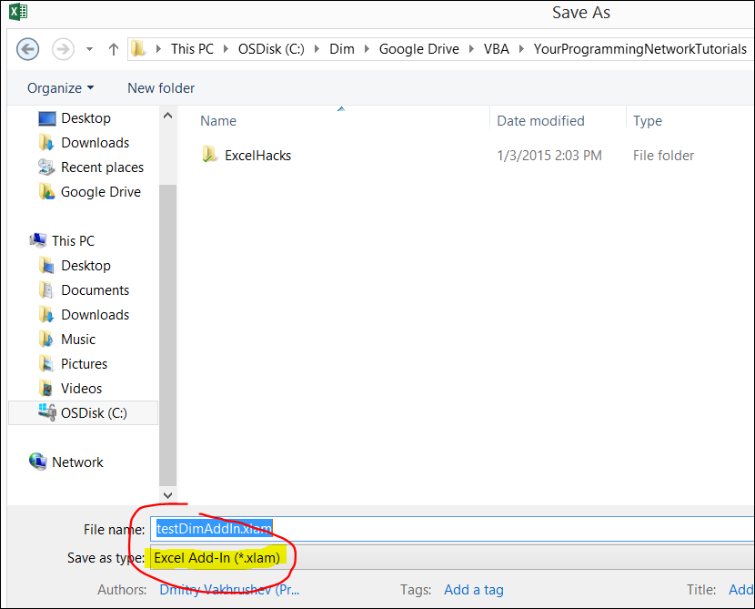

Now close all .xls files.

Open a new workbook

Go to Developer tab – Add-Ins 🡪 click "browse"

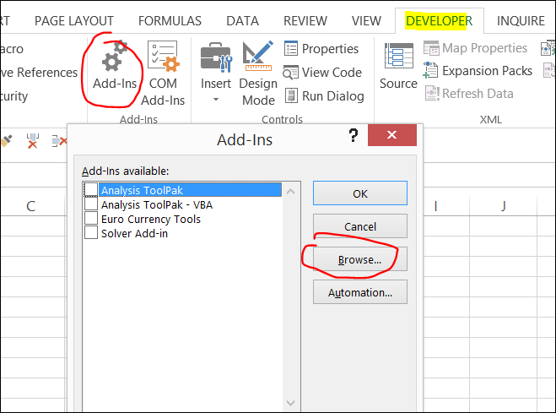

Find your file on the file system and click Ok

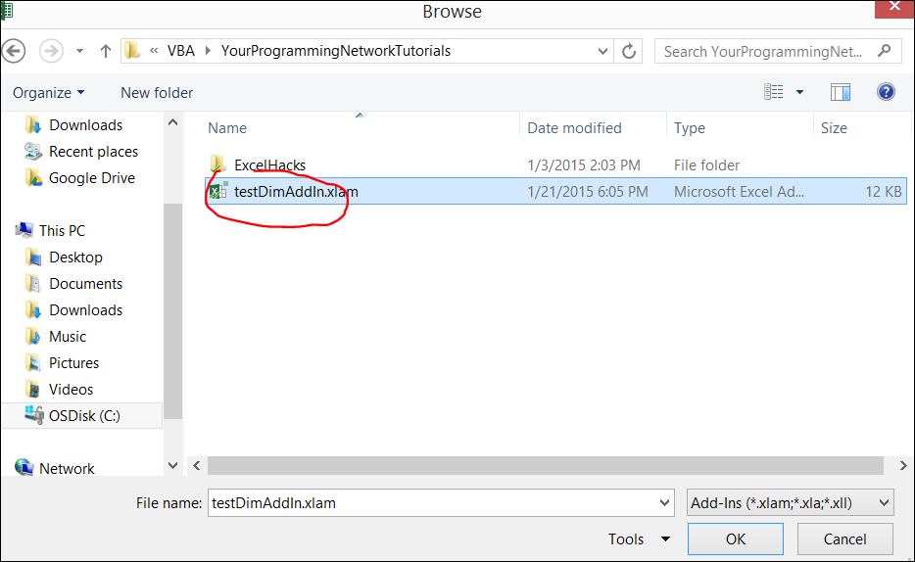

The new add-in will appear in the list of Add-ins

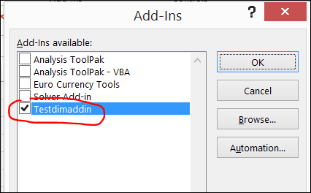

Now the functions and subs of the add-in are available

# **Excel 2010 VBA Tutorial 106 - Assign a Macro to right click menu**

<https://www.youtube.com/watch?v=POFRN2c7L6E&index=106&list=PLS7iHfqXNVhK3yzd_4XS5k4zsvnu2mkJC>

Create a sub

Sub L106_AssignMacro()

ActiveCell.Value = "Hello World!"

End Sub

Then click on ThisWorkbook

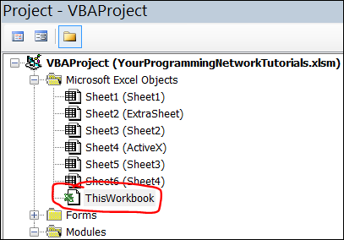

Select

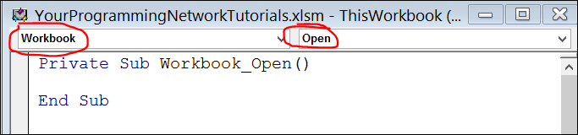

Print the following code

Private Sub Workbook_Open()

Dim contextMenu As CommandBar

Set contextMenu = Application.CommandBars("Cell")

With contextMenu.Controls.Add(Type:=msoControlButton, Before:=1)

.OnAction = "'" & ThisWorkbook.Name & "'!L106_AssignMacro"

.FaceId = 351

.Caption = "Hello"

.Tag = "My_Cell_Control_Tag"

End With

End Sub

Also to remove this button when we close this workbook and open a new one

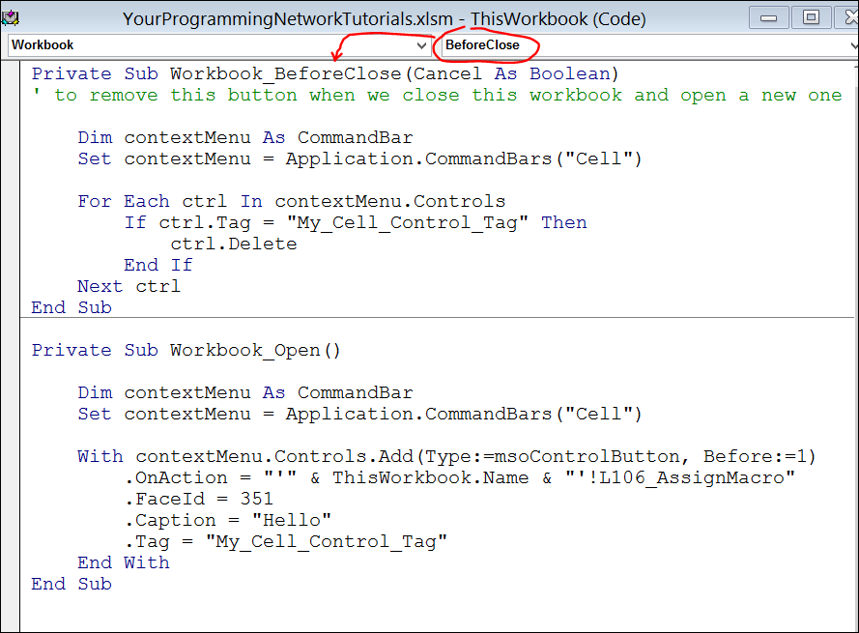

Private Sub Workbook_BeforeClose(Cancel As Boolean)

' to remove this button when we close this workbook and open a new one

Dim contextMenu As CommandBar

Set contextMenu = Application.CommandBars("Cell")

For Each ctrl In contextMenu.Controls

If ctrl.Tag = "My_Cell_Control_Tag" Then

ctrl.Delete

End If

Next ctrl

End Sub

Now the right click button will show an extra icon.

When you click on it the assigned subroutine will be executed



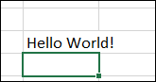

Now t